**Frames:**

**Image:**

**<html>**

**<head>**

**<title>Image Of Router</title>**

**</head>**

**<body bgcolor="blue">**

**<image src="C:\Users\JOYSREE\Pictures\Saved Pictures\New folder\download.jpg" height=75% width=100% >**

**<h1 align="center"><font color="red"><u><strong>ROUTER</font></u></strong>**

**</body>**

**</html>**

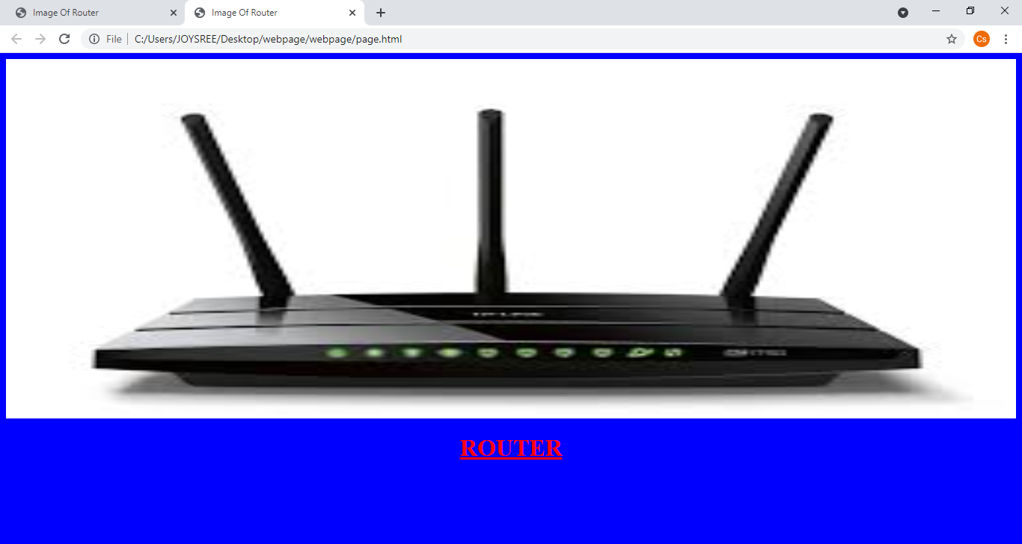

**Description:**

<html>

<head>

<title>DESCRIPTION</title>

</head>

<h1 align="center"><font color="navy"><u><strong>ROUTER</font></u></strong></h1>

<h2 align="left"><font color="copper">Defination:</font></h2>

<body bgcolor="aqua"><font size="4"><font color="copper">A router receives and sends data on computer networks. Routers are sometimes confused with network hubs, modems, or network switches. However, routers can combine the functions of these components, and connect with these devices, to improve Internet access or help create business networks.<br>

<h3 align="left"><font color="copper">Types of Router:</font></h3>

<ol type="a">

<li>Wired router</li>

<li>Wireless router</li>

<li>Core router and edge router</li>

<li>Virtual router</li>

</ol>

</font>

</font>

</body>

</head>

</html>

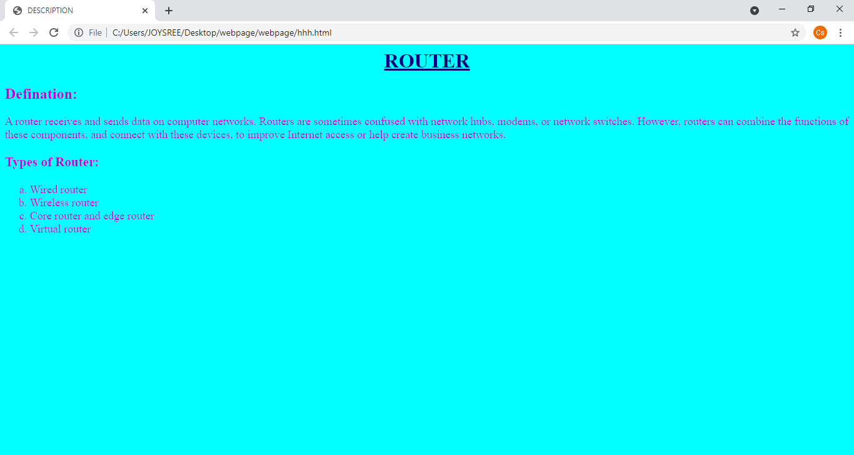

**Link:**

<html>

<head> <title>create link</title></head>

<body bgcolor="pink">

<h1><font color="green"><strong>CLICK HERE TO KNOW ABOUT ME:</strong></font></h1>

Click<a href="file:///C:/Users/JOYSREE/Desktop/webpage/webpage/tin.html">here</a>to go to link.

</body>

</html>

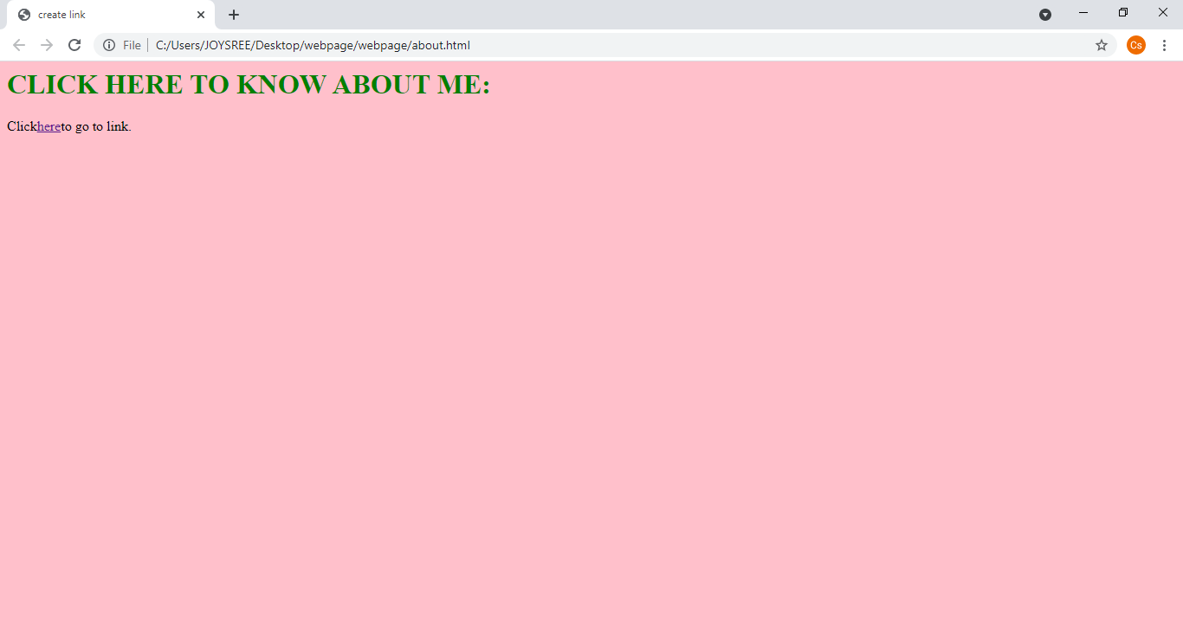

**My Biodata:**

<html>

<head>

<title>click here</title>

</head>

<body bgcolor="orange">

<h1><font color="lime"><u><strong>MY BIODATA</font></u></strong></h1>

<align="left"><strong><font color=brown">

NAME:<INPUT TYPE="TEXT"Name="Name"SIZE="20" MAXLENGTH="25"><BR><BR>

DEPT:<INPUT TYPE="TEXT"Name="DeptName"SIZE="40" MAXLENGTH="35"><BR><BR>

SUBJECT:<INPUT TYPE="TEXT"Name="RollName"SIZE="15" MAXLENGTH="25"><BR><BR>

ROLL:<INPUT TYPE="TEXT"Name="SubName"SIZE="15" MAXLENGTH="20"><BR><BR>

</font></strong>

</body>

</html>

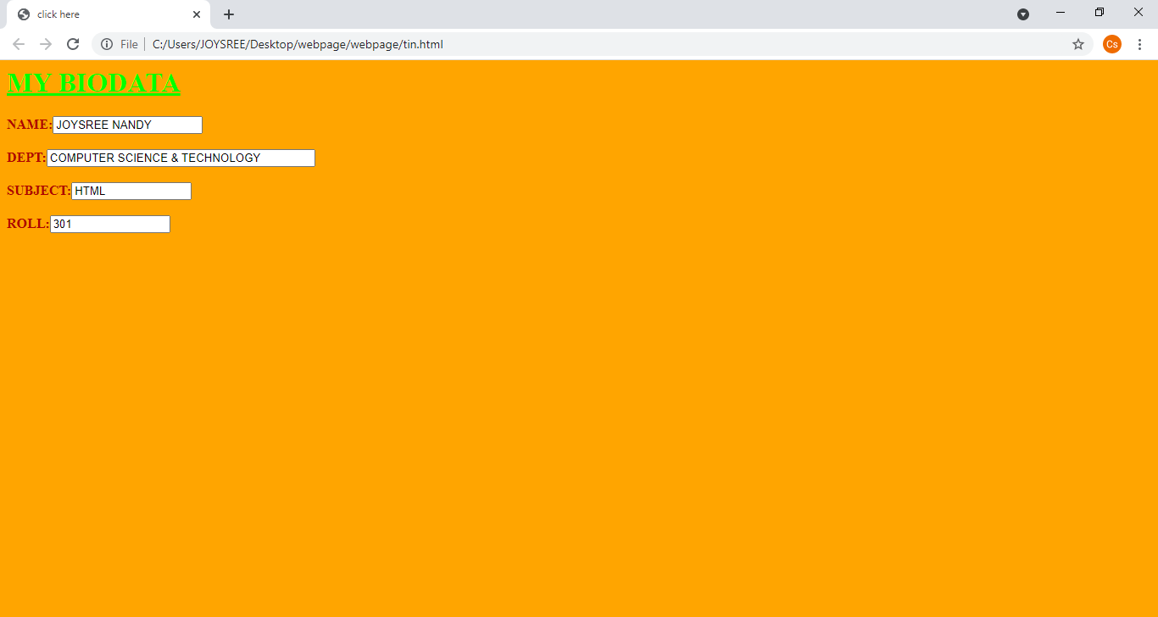

**Frame Code:**

<html>

<head>

<frameset rows="50%,*">

<frameset cols="35%,*">

<frame src="page.html">

<frame src="hhh.html">

</frameset>

<frame src="about.html">

</frameset>

</body>

</html>

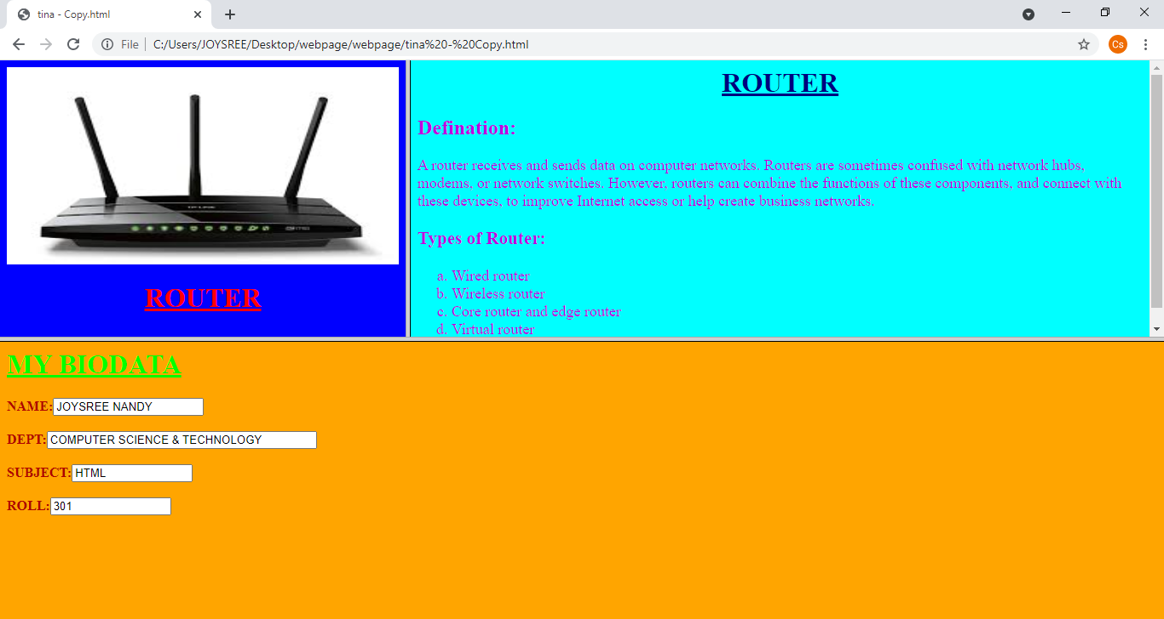**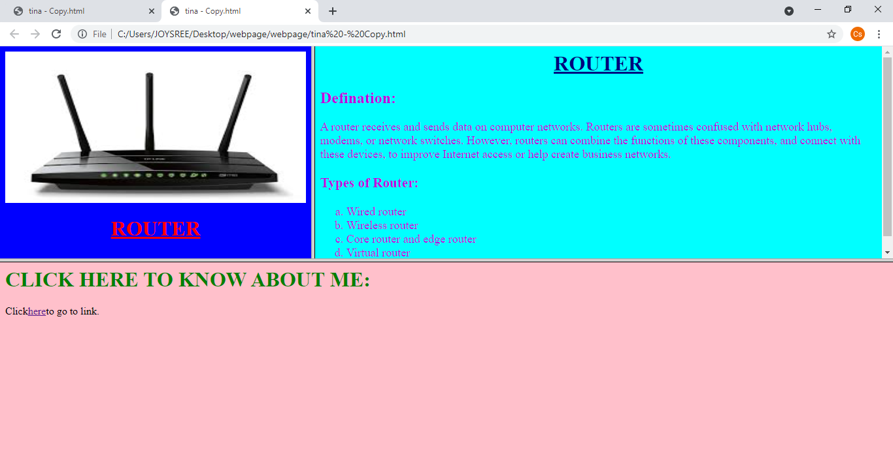OUTPUT:**